Video Link for residual plot;

<https://www.khanacademy.org/math/ap-statistics/bivariate-data-ap/assessing-fit-least-squares-regression/v/residual-plots>

### Residual Plot

A **residual plot** is a graph that shows the [residuals](https://stattrek.com/Help/Glossary.aspx?Target=Residual) on the vertical axis and the independent variable on the horizontal axis. If the points in a residual plot are randomly dispersed around the horizontal axis, a linear regression model is appropriate for the data; otherwise, a non-linear model is more appropriate.

Below, the residual plots show three typical patterns. The first plot shows a random pattern, indicating a good fit for a linear model.

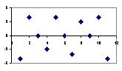

The other plot patterns are non-random (U-shaped and inverted U), suggesting a better fit for a non-linear model.

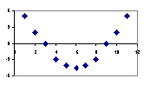

**Non-random: U-shaped curve**

